ServletContextListener 監聽器( Interface )
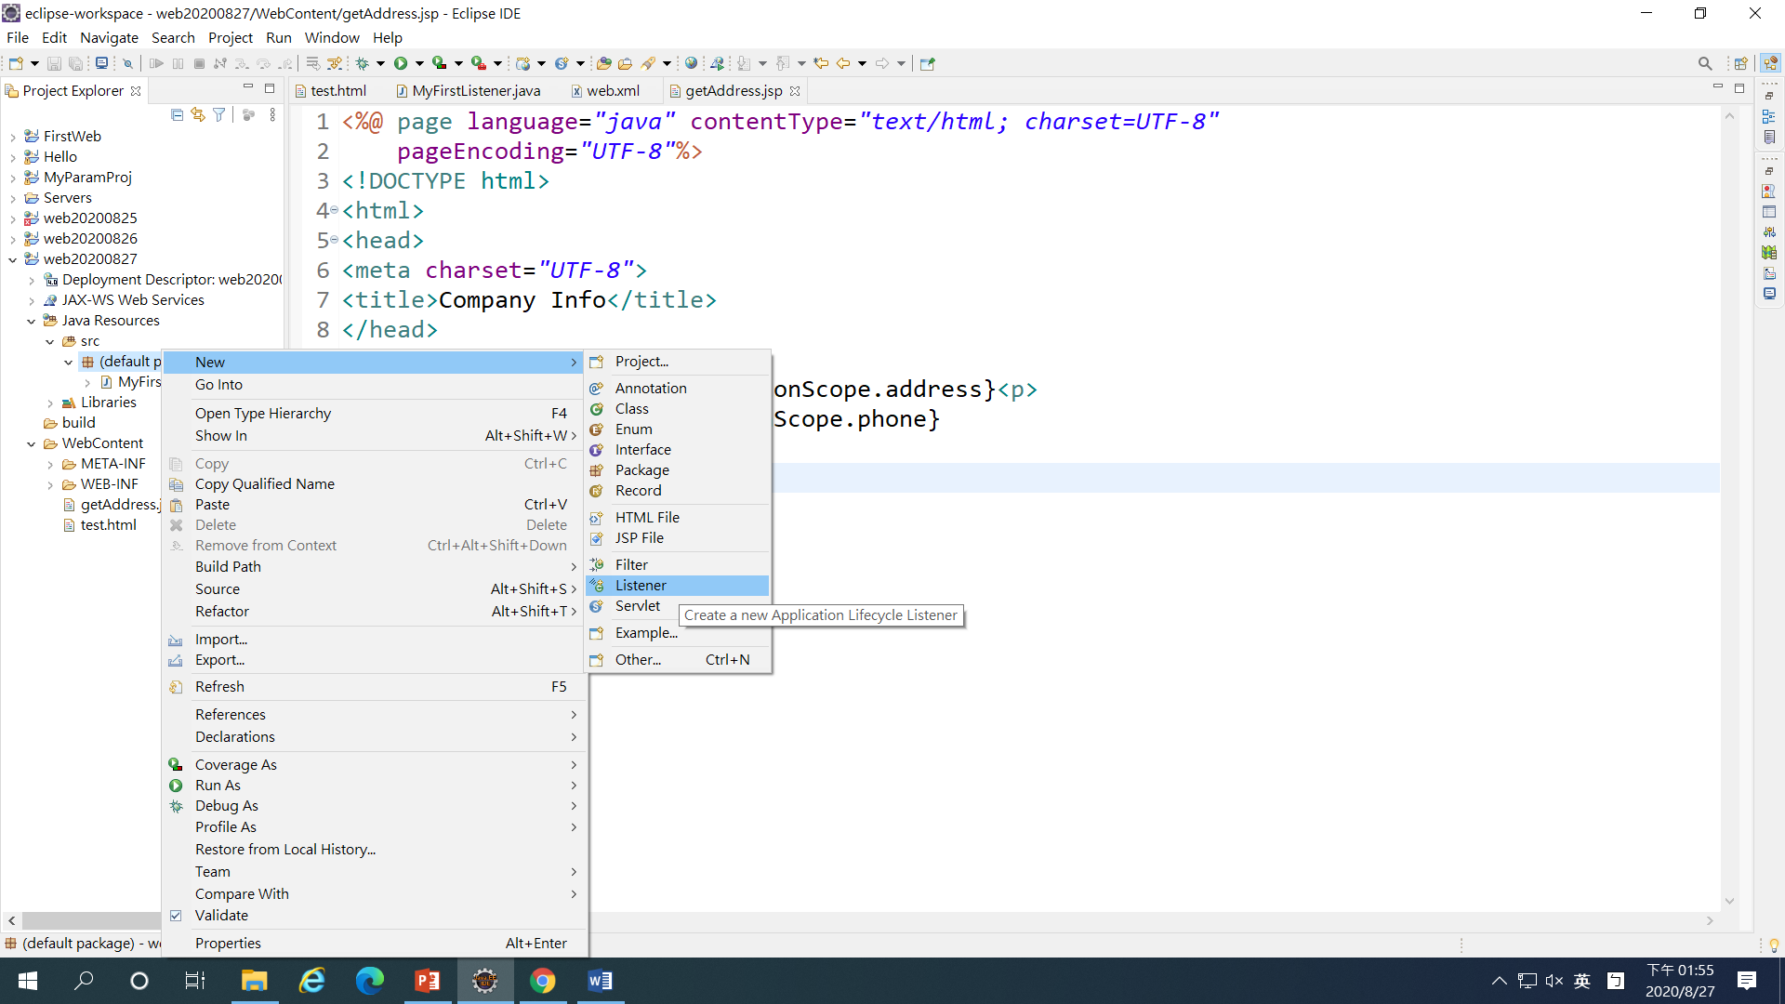
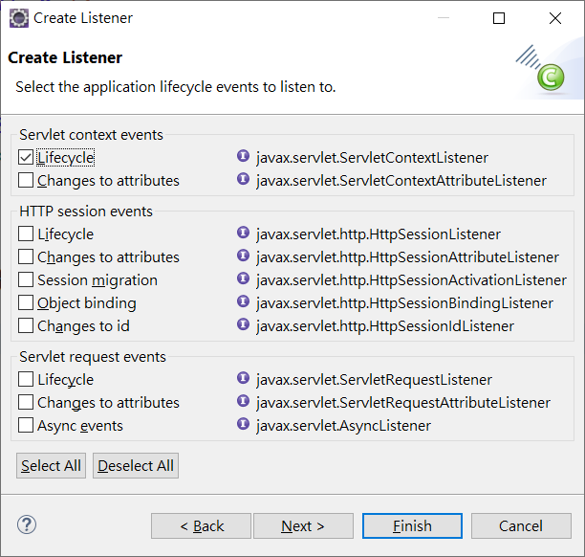
- @WebListener //annotation
- implements ServletContextListener

@WebListener //annotation
public class MySecond implements ServletContextListener {

/**
* Default constructor.
*/
public MySecond() {
// TODO Auto-generated constructor stub
}

/**
* @see ServletContextListener#contextDestroyed(ServletContextEvent)
*/
public void contextDestroyed(ServletContextEvent sce) {
// TODO Auto-generated method stub
}

/**
* @see ServletContextListener#contextInitialized(ServletContextEvent)
*/
public void contextInitialized(ServletContextEvent sce) {
// TODO Auto-generated method stub
ServletContext app=sce.getServletContext();
String name=app.getInitParameter("admin");
app.setAttribute("admin", name);
}

}

Web.xml
ServletContext getInitParameter
<context-param>
<param-name>admin</param-name>
<param-value>Jerry</param-value>
</context-param>

取的Servlet Context Attribute
<%@ page language="java" contentType="text/html; charset=UTF-8"
pageEncoding="UTF-8"%>
<!DOCTYPE html>
<html>
<head>
<meta charset="UTF-8">
<title>Manager Page</title>
</head>
<body>
administrator name: ${applicationScope.admin}
</body>
</html>

